5.a) Learn about stateful and stateless widgets.
Stateless widget

import 'package:flutter/material.dart';

void main() => runApp(const StatelessExampleApp());

class StatelessExampleApp extends StatelessWidget {
const StatelessExampleApp({super.key});
@override
Widget build(BuildContext context) {
return MaterialApp(
home: Scaffold(
appBar: AppBar(title: const Text('Stateless Widget Example')),
body: const Center(
child: Text('Hello, Flutter!', style: TextStyle(fontSize: 24)),
),
),
);
}
}
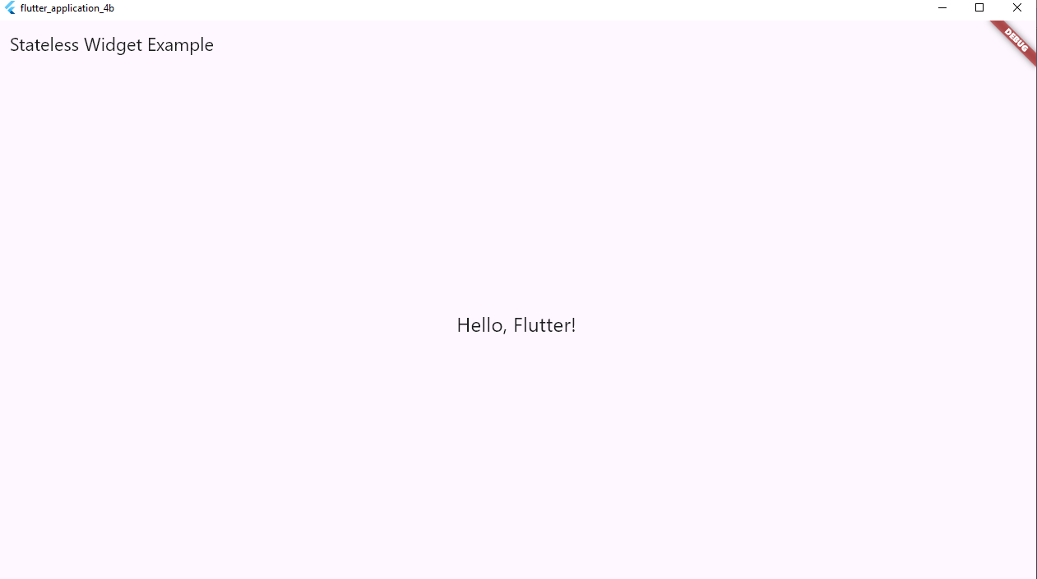

StatefulWidget

import 'package:flutter/material.dart';
void main() => runApp(const GrowApp());

class GrowApp extends StatelessWidget {
const GrowApp({super.key});
@override Widget build(BuildContext context) => const MaterialApp(home: GrowScreen());
}

class GrowScreen extends StatefulWidget {
const GrowScreen({super.key});
@override State<GrowScreen> createState() => _GrowScreenState();
}

class _GrowScreenState extends State<GrowScreen> {
double _scale = 1.0;
void _grow() => setState(() => _scale += 0.1);
@override Widget build(BuildContext context) {
return Scaffold(
appBar: AppBar(title: const Text('Tap to Grow')),
body: Center(
child: GestureDetector(
onTap: _grow,
child: Transform.scale(
scale: _scale,
child: Container(width: 100, height: 100, color: Colors.orange),
),
),
),
);
}
}

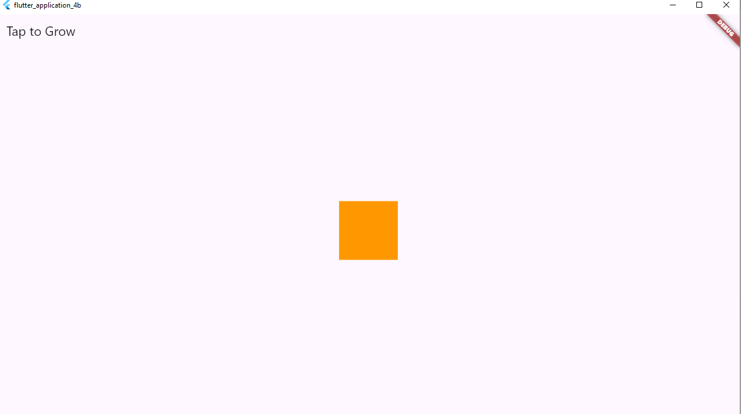
By tapping on the widget the size of the box keep on increasing
